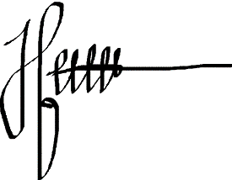



M A K A S S A R

This is to certify that

Firqhal Dzikriansyah

**BEST GFGFGFGFGFGFGFFDDFDFDFEMPLOYED**

**At Bar Department**

**Period 01 March 2022 – 01 April 2022**

Makassar, 29 january 2023

**HARYTASNI**

OPERATIONAL MANAGER

**EMPLOYED**